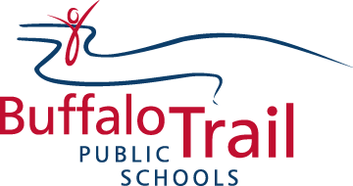
Buffalo Trail Public Schools Professional Growth Plan

Name: ______________________________________
School: ______________________________________

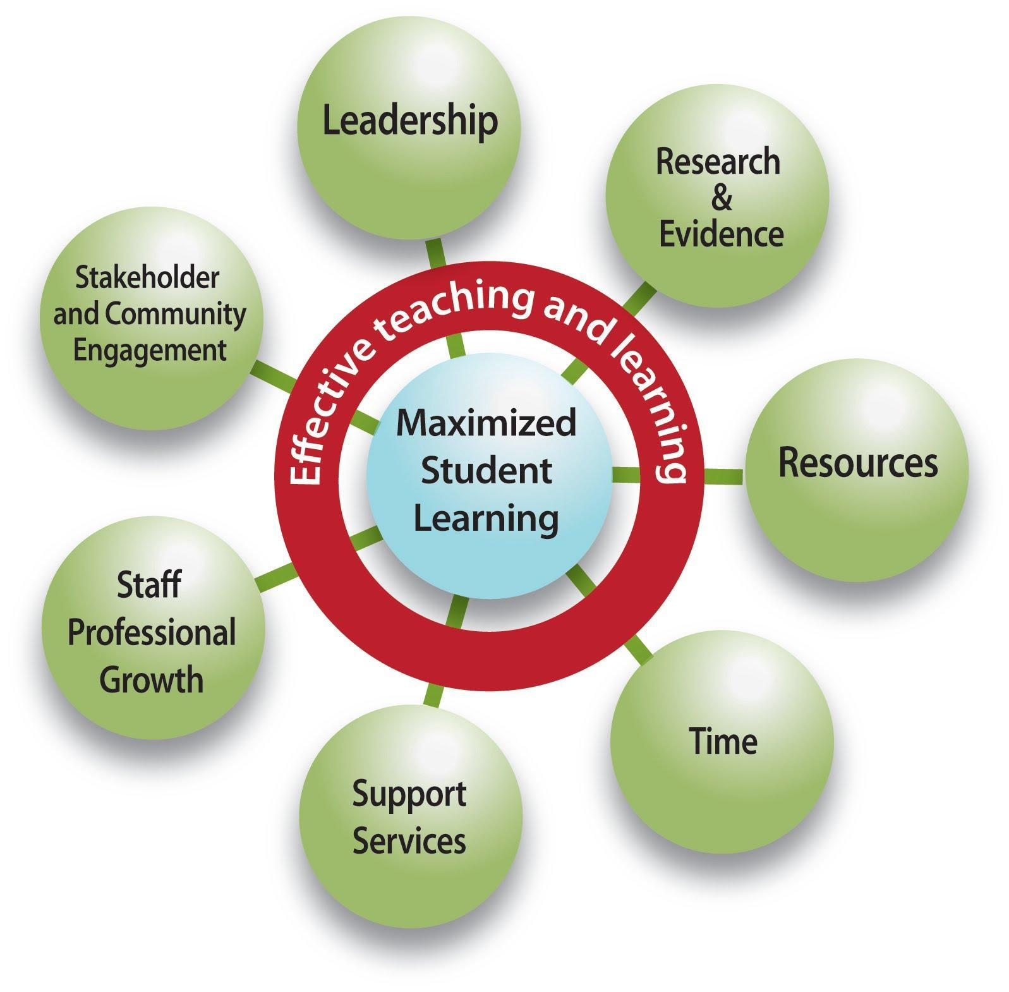
Buffalo Trail Public Schools is committed to maximizing student learning, in a safe and caring environment, supported by a highly effective team. Many factors contribute to student learning, but research shows that the most direct factor impacting student learning is effective teaching (Stronge, 2010; Marzano, 2003, 2010; Hattie, 2003; Barber and Mourshed, 2007, Leithwood, 2009; etc.).
This BTPS Professional Growth Plan supports learning that is collaborative, continuous, embedded in daily practice and focused on student achievement. We strive to build on and strengthen our successes and the PGP provides every educator an opportunity to enrich practice. Throughout our work, the ultimate goal of professional growth and development is improved student learning.
The BTPS essential conditions graphic represents how all members of BTPS impact effective teaching and learning; and thus assist in maximizing student learning. The same graphic can represent the many roles and responsibilities that a staff member must consider as they strive to be the most effective professional possible.
The PGP is a document for you and your professional growth, not for evaluation. There are no maximum number of goals and/or strategies required. Rather, this document should: reflect your changing needs and interests as a professional, be a living, breathing document that is written and rewritten to be current throughout your year(s), and it should reside in your possession.

Goal #1:
Strategies or Actions: | - What steps will you take to achieve your goal?  - What type of professional learning will be planned or implemented?
1.
2.
3.
Reflection/Indicator of Success
1. How successful have I been in meeting my goal?

2. How has my professional practice improved?

3. How has student learning improved?

Goal #2:
Strategies or Actions: | - What steps will you take to achieve your goal?  - What type of professional learning will be planned or implemented?
1.
2.
3.
Reflection/Indicator of Success
1. How successful have I been in meeting my goal?

2. How has my professional practice improved?

3. How has student learning improved?

Goal #3:
Strategies or Actions: | - What steps will you take to achieve your goal?  - What type of professional learning will be planned or implemented?
1.
2.
3.
Reflection/Indicator of Success
1. How successful have I been in meeting my goal?

2. How has my professional practice improved?

3. How has student learning improved?

Reflective Comments and Discussions

The PGP has been reviewed and discussed at these times during the school year. This should include, but not be limited to an initial meeting with your principal or supervisor in the early fall, during the year and a wrap-up conversation in the late spring.
PGP Initial Conversation - all staff | PGP Conversation 2 - teachers only | PGP Final Conversation - all staff
_____________________________________  Employee’s Signature | ____________________________  Employee’s Signature | ____________________________  Employee’s Signature
__________________________________  Employer’s Signature  ________________________________  Date (between Sept and October 31 or first two months of employment) | __________________________________  Employer’s Signature  __________________________________  Date (between November - April) | ___________________________________  Employer’s Signature  ____________________________________  Date (between April and June)
Follow up items:

